Lab 1 – Report
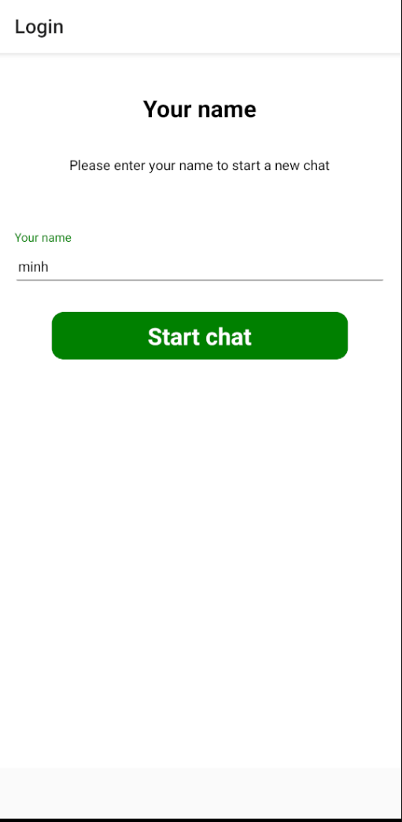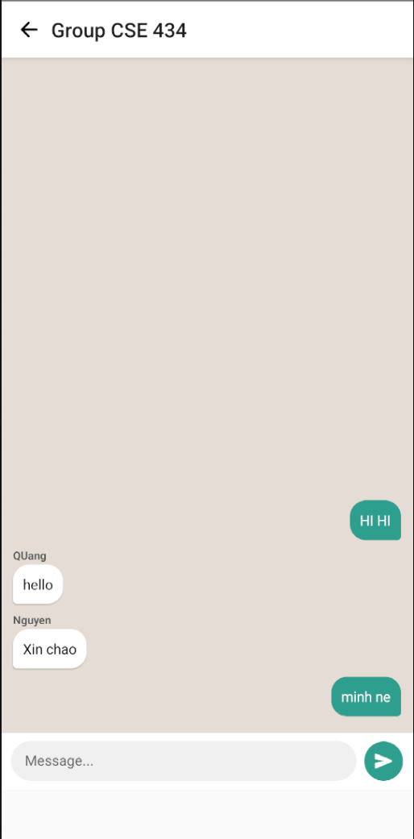
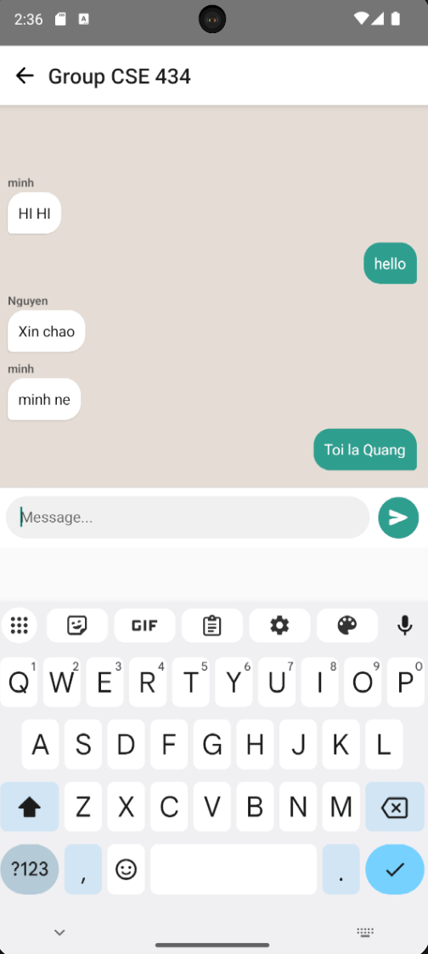
Github repo: https://github.com/nqminh4604/CSW-434/tree/main/Lab/Lab%201

